**MESD Documentation LMS-25-Setup-school-terms**

**Purpose**

To allow for courses to be grouped by time periods.

**Background**

A school term is a group of courses over a period of time. We aim to assign courses to periods of time throughout the school year.

**Setup Process**

**Disable Email-based self-registration**

Navigate to Site Administration -> Courses -> Add a new course

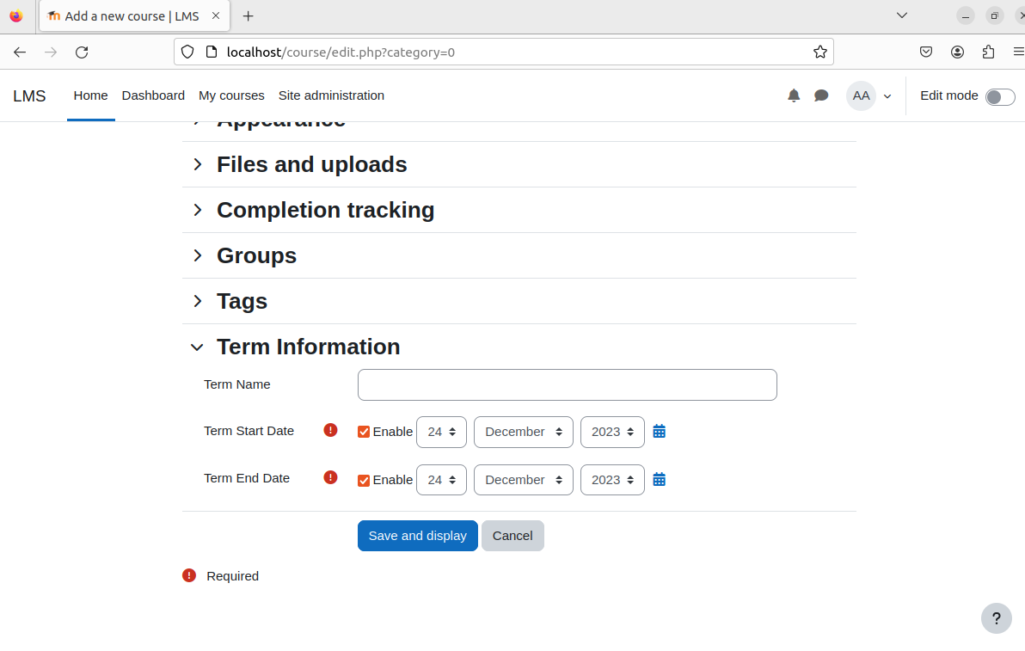

Navigate down to the Term Information Section and input data about your term or semester.